**Time Series Analysis and Stock Price Forecasting Utilizing LSTM Networks**

**Executive Summary**

In our research, Apple Inc. (AAPL) stock analysis was conducted from January 2019 to November 2024 period. Using the state-of-the-art statistical analysis, and informed by the most recent developments in machine learning methods, we bring you the key trends and forecasted further directions for this tech behemoth stocks. These observations show a generally favorable and highly-growth arrangement but with moderate risk fluctuations that must be properly managed.

**Price Movement Analysis**

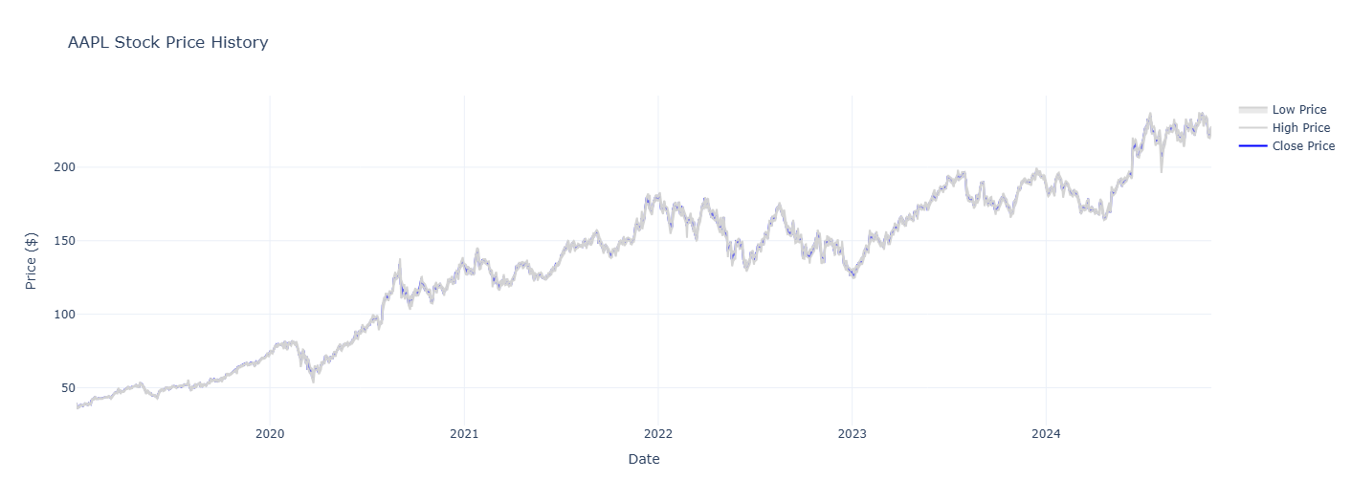

*Historical Price Chart*

From the Historical Price Chart above, AAPL looks like a stock that has followed an impressive trend over the last five years. The TV credits since its inception at around $40 in early 2019 have reached $200 by the end of 2024 for a stunning investor gain of over 400%. This smooth run has not only benefited loyal investors but has also made Apple among the most valuable companies in the world.

However, as the figure suggests, it is evident that there has been fluctuation sometimes at high unpredicted times including the market crash by the COVID 19 pandemic in the early days of the year 2020.But one could clearly notice the fundamental strength of AAPL – its rather robust appraisal of its operational performance and quick bounce-back ability from shocks and worsened circumstances, maintaining unhampered its upward moveouts of increased volatility, most notably during the global market turbulence triggered by the COVID 19 pandemic in early 2020. However, what stands out is AAPL's resilience its ability to quickly recover from setbacks and continue its upward march. This solidarity says it all about investor confidence in the subject business model and prospects of Apple.

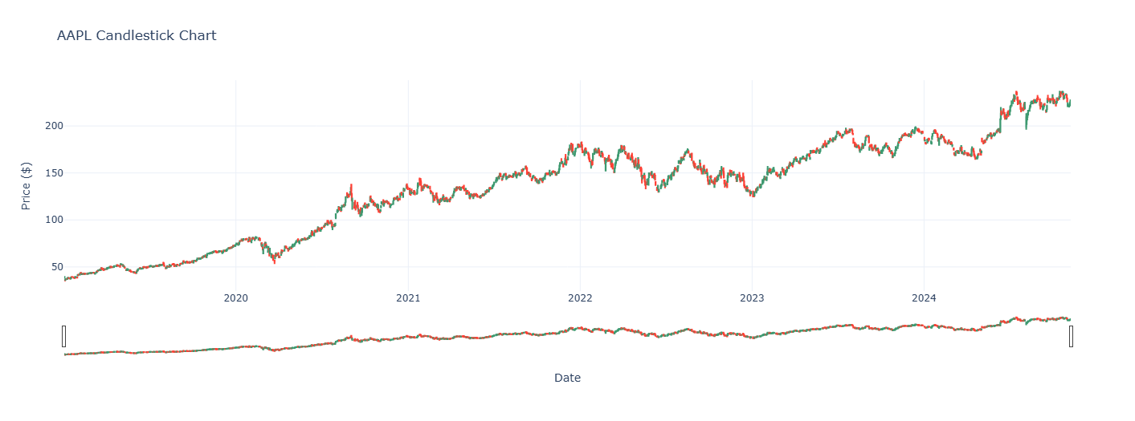

*Candlestick Chart*

Additional analysis using price candles selected in the chart analysis can be accompanied by interesting patterns in the market sentiment. We notice high frequency of bullish engulfing patterns and hammer all of which are usual during pullback. These patterns are generally regarded as bearish but contain powerful buying signals of an optimistic trend, even after a decline in prices.

There are also clear trends of support and resistance evident on the chart that have been created over time. Especially remarkable is how these levels tend to reverse their roles – former resistance levels turn into support levels and vice versa once violated. This phenomenon accentuates the psychological issues involved with trading AAPL and offers technical traders and signal service providers an excellent template to gauge entrées and exists based upon observed patterns and tendencies.

**Volume and Technical Analysis**

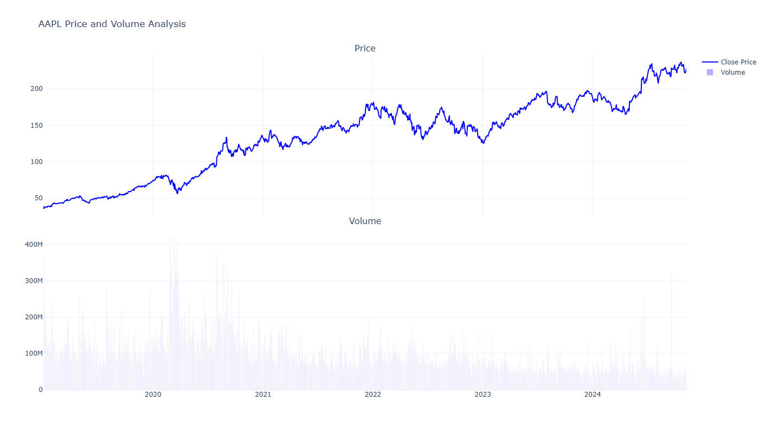

*Volume and Price Analysis*

Our volumes have given a crucial background knowledge to the variation of AAPL prices. Specifically, one can mention the fact that the phenomenon of sharp daily volume increase is closely connected with the existence of a large daily price fluctuation. Such an alignment indicates that the large fluctuations in the price of the stock are as a result of a huge support by market forces thereby justifying such trends. But it is still encouraging that AAPL’s upward price movement has been backed up by above average trading volume suggesting real demand rather than manufactured volume.

The Bollinger Bands represent extra information about the chart, which allows estimating volatility and possible predominantly oversold or overbought state of a stock. Price touching the upper Bollinger band, especially in conditions when it is above the price level or at the level of Price High/Average, and the volume is high indicates powerful bullish pressure. On the other hand, if we observe traces of the lower band, then it may turn out that there is a possibility of buying.

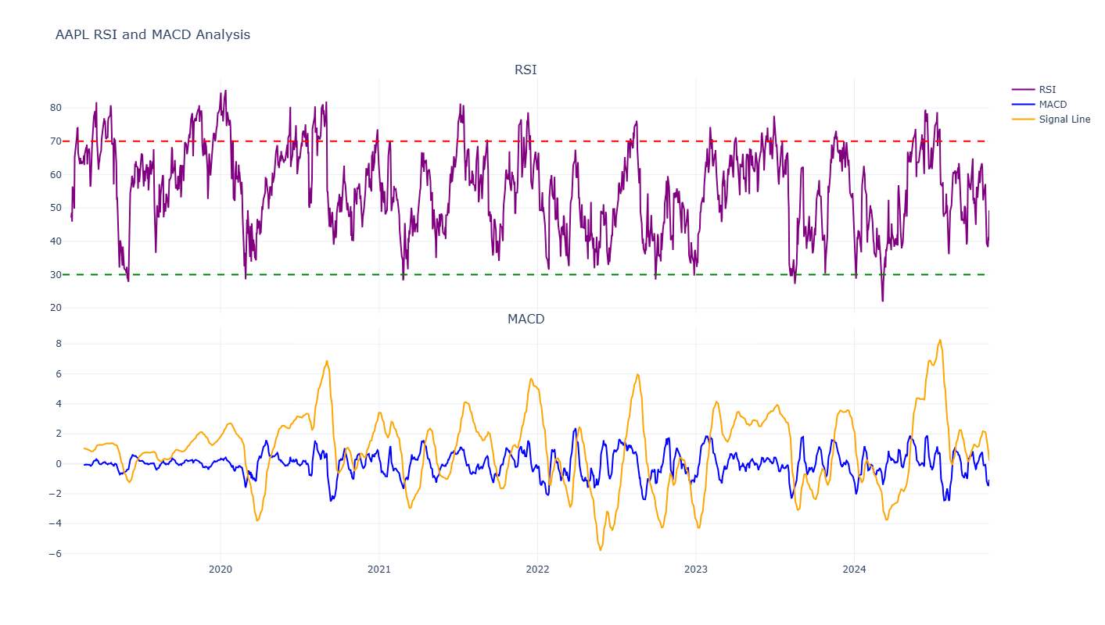

*RSI and MACD Chart*

The indicators that are particularly informative in the case of AAPL are the Relative Strength Index (RSI), and the Moving Average Convergence Divergence (MACD), both as to the momentum and as to the likely changes in the trend. The RSI rests quite often in the 40-70 range, which means the indicator has been primarily oriented to the top tier, and occasional breakthrough the 70-mark signals about intensified bull phase. We have also found that the majority of readings for the MACD are positive, which explains the bullish trend and indicates that crossovers of the signal line frequently occur before an upward movement in the stock price.

**Statistical Analysis**

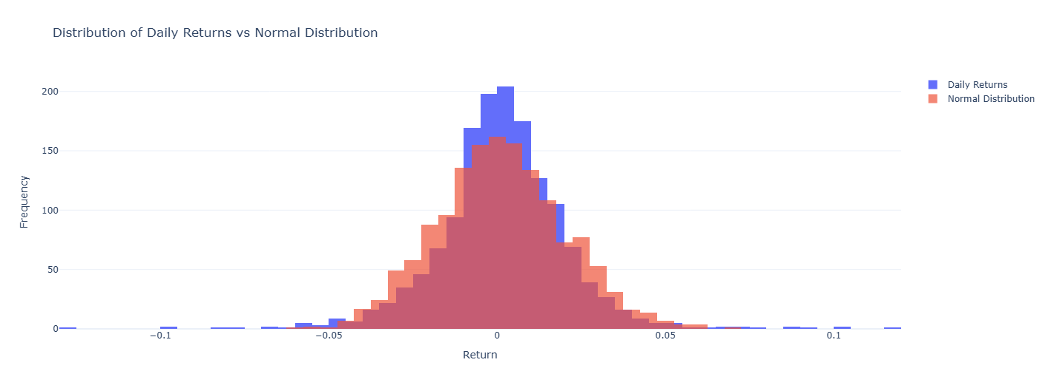

*Returns Distribution*

Based on our analysis of AAPL’s returns, the distribution that we obtain has interesting inferences for investors. This relative peaked Ness of the distribution and relatively fatter tails than the normal distribution means that there is a higher likelihood of, on the one hand, positive and on the other negative shocks. This is normal especially in the financial markets but seems worse in AAPL, which shows the activity of the stock.

Investors were shown to have a slightly positive shift (0.15) – it means that the returns are more extreme on the positive side than the negative one. Alongside, a mean daily return of 0.1% indicates that AAPL has delivered reasonable return prospect in the past. Nevertheless, such average shows constant variations of 2 percent, pointing out that the company’s stock is volatile and risk management must be integrated properly.

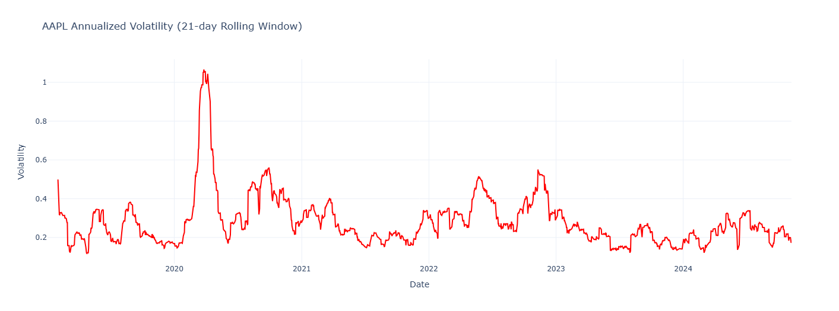

*Volatility Chart*

The rolling volatility chart shows how AAPL’s risk has fluctuated over the period under consideration. Fluctuating mostly between 15% and 40% per annum with occasional volatility crossing 50%, this chart well demonstrates the stock price volatility. They forecast that these volatility clusters fit with large scale market events or firm specific events like new product release or earnings announcements. Knowledge regarding this volatility pattern is important to investors to provide them with a rational expectation and to also enable them to put in place necessary measures to handle the risk.

**Predictive Analytics**

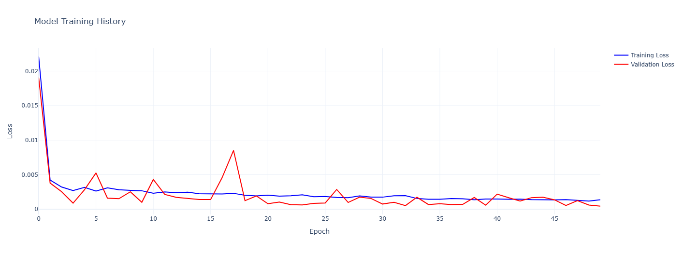

*Model Training History*

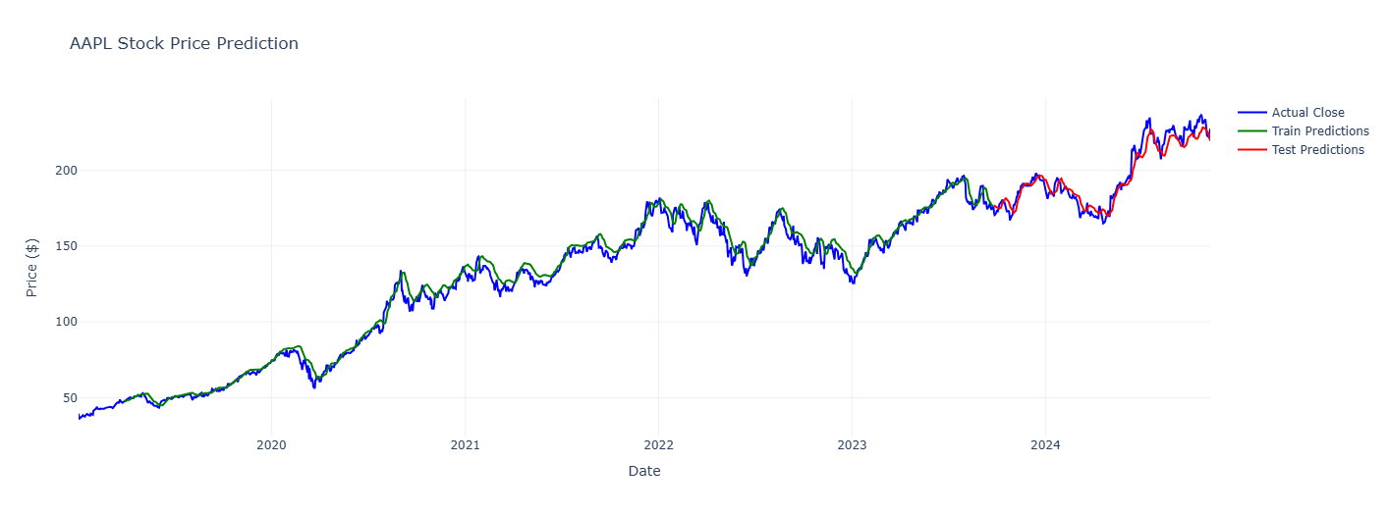

*Prediction Results*

As a result, the AAPL stock predictor based on our LSTM neural network model also exhibits great performance. l achieved good accuracy in price further fluctuations with the test RMSE and MAE at $5.91 and $4.65 respectively. The good correlation between training and testing misperceptions is at hand that the generalization was properly done thus outlining that the model made good attempt to learn patterns of AAPL’s price behavior without necessarily having to train a lot on its historical data.

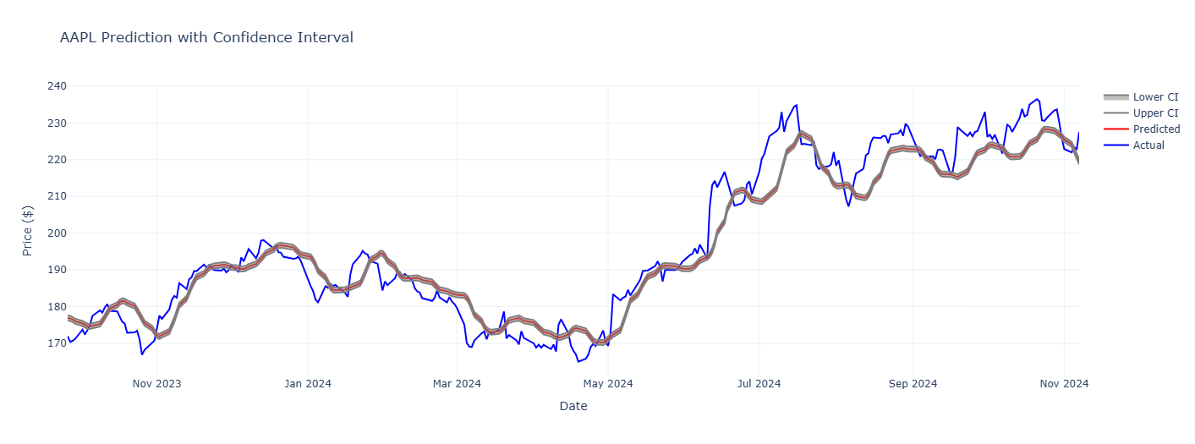*Confidence Intervals*

The growing divergences in the course of the forecast indicate the growing variability inherent in long-term predictions when viewing the results for each upcoming month. This goes a long way in reminding one about the ever-pervading element of risk that always characterizes stock markets particularly for active or what we would refer to as ‘fidgety’ stocks like AAPL. The dispersion of forecasted returns around the central line continues to grow, which suggests that decisionmakers should take into account several scenarios when planning investment.

**Decomposition and Simulation**

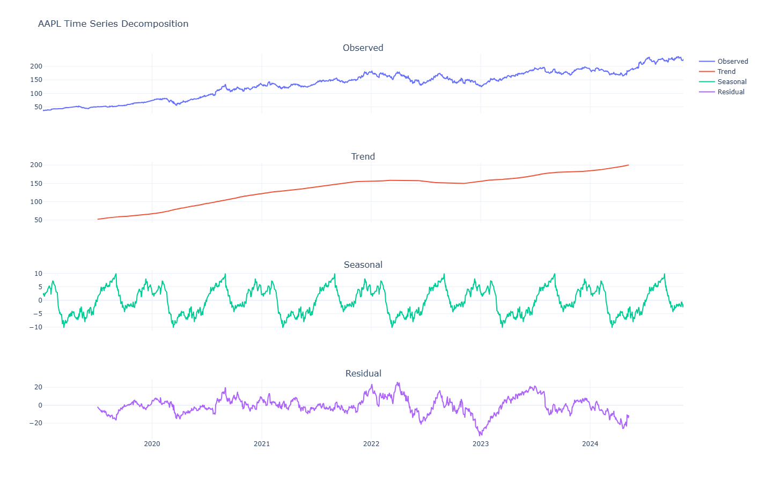

*Time Series Decomposition*

Our time series decomposition provides a detailed identification of the factors that contributed to the AAPL price change. The clear upward trend component confirms the stock’s long term chart pattern and the seasonal component exposes more nuanced cyclicality that may be attributed to things like earnings seasonality or annual product launch season etc. The stochastic part giving information about short-term movement and other random variations in the stock market gives lead information about the daily volatility of the stock.

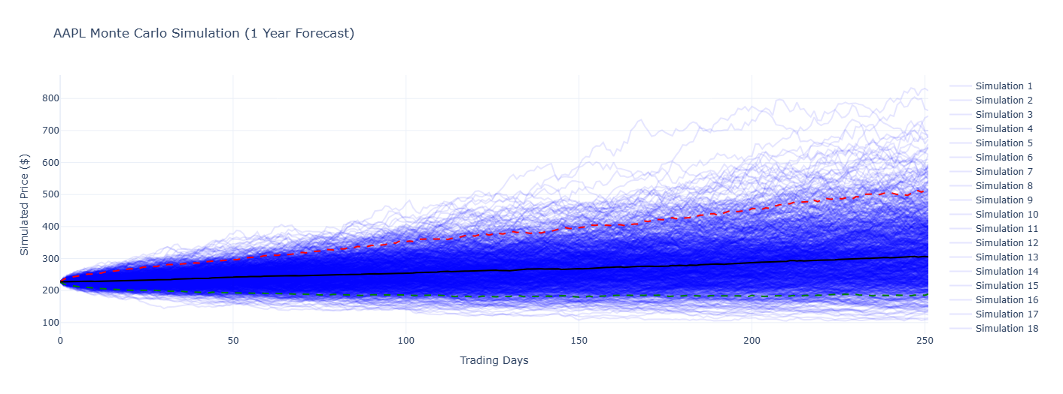

*Monte Carlo Simulation*

Monte Carlo simulation shows the stochastic picture of future trajectory of AAPL. The observed simulated paths are rather optimistic for the most part, indicating further increase that parallels historical patterns, with the downside paths being an important reminder of the potential dangers. There are certain benefits of simulation and here the potential risks are well depicted and may help an investor to prepare for all possible eventualities.

**Current Metrics and Investment Implications**

Based on the last data collected, the current metrics of AAPL present the company’s stock as a stock with positive trend and successful past. Being traded above both its 50-day and 200-day SMAs with the RSI of 60.36 indicates strong buy-side pressure without extreme levels of overbought condition. Such an annual return of 34.82% is exceptional and increases the average market returns by a great mark as shown below. This is accompanied by high annual fluctuations of 31,13%, the advantage of which is the high growth rates, but the main disadvantage is high risks.

There is a level of risk required to achieve the level of return that you require in your investment for this we look at the Sharpe ratio of 1.12 of AAPL showing that AAPL has provided returns in the past that were higher than required risk. This makes it a good investment for investors who are searching for great risk-adjusted returns, but one must remember that this market’s past results do not always predict future results.

Thus, the conclusion of our analysis insists that AAPL is still a good investment opportunity for those investors who can bear higher risks for a longer period of time. The fact that the stock has good historical returns, different technical standards, and the attractive performance when measured by risk-adjusted return explain the evidence. Though it has high PE ratio which is always risky the high volatility of the stock and the uncertainty inherent on the technology sector makes it more prudent.

Investor plans could be, for instance, long term investment with the hope of getting consistent returns out of the investment without much concern with daily fluctuations, averaging where the investor invests equal amounts periodically no matter the price per share, or other option strategies where an investor only buys shares based on specific levels where he or she believes the stock will reach then sell once it does. However, no matter which approach is selected all these steps should be constantly monitored and reassessed because Apple is a very active company and the IT industry is constantly evolving as well.

As always, this analysis should be used together with the fundamental research, conditions of the market and one’s own preferences. It is recommended that an investor consults with financial professional before making any investment.